Where have all the brewsters gone? Ninkasi to Annie Johnson
Beer and beer culture now might very much seem like a male dominated society, and indeed brewing itself is pretty much a beardy boys club but take a trip through brewing history and it’s a whole different hop addition.
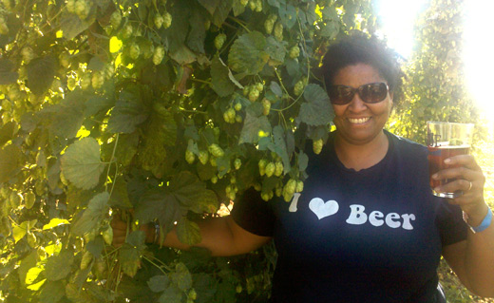
Annie Johnson 2013 Homebrew of the year – photo courtesy of the American Homebrewers Association
In 2013 I squealed excitedly when I read that the American Homebrewers Associations' homebrewer of the year was awarded to a woman named Annie Johnson. I was in equal measure excited and shocked, excited to see that another woman who homebrews was recognised at such a high level. Shocked because, well let’s be honest, how many women do you know who homebrew, and out of them how many get treated and respected like a male brewer would? Is the beer world changing?
The truthful answer to this is, well actually the beer world has already changed, but in the opposite direction.

Brewing in the ancient world
Although they argue over the specific origins, archaeologists who study fermentation do agree on one thing: the vast majority of ancient brewers (or brewsters to be correct) were women. Brewing was simply women’s work.
“While men were out hunting, women were out gathering the ingredients they needed to make other foods and drink to go with the woolly mammoth or mastodon.” Dr. Patrick McGovern, the University of Pennsylvania biomolecular archaeologist - Known as the Indiana Jones of ancient wines and ales
Traditionally, historians locate the birthplace of beer in the area of Mesopotamia, more specifically ancient Babylon, Sumeria, and Egypt although new discoveries are being made all the time to date brewing even further back in history but the earliest written evidence for beer production are from the Mesopotamian area around 3500 BCE (before the common era) and some of these called upon a woman—well, strictly speaking, a goddess—to ensure that the magic of fermentation occurred.
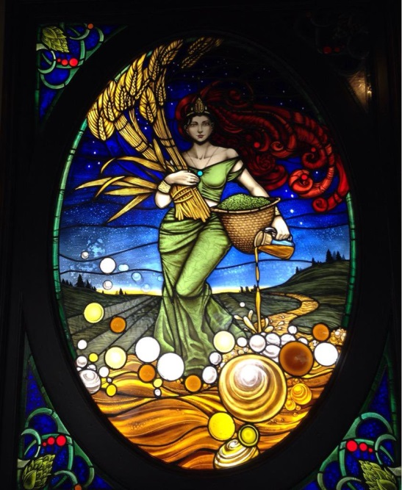
Sumerian brewsters or “Sabtiem” enjoyed tremendous respect, in part because they probably also served as priestesses of the revered beer goddess, Ninkasi. Sumerians believed Ninkasi oversaw the brewing process and “worked” as head brewer to the gods, who’d gifted beer to humans to preserve peace and promote well-being.
The name Ninkasi meant "the lady who fills the mouth" and in a hymn to Ninkasi found on cuneiform tablets from around 1300 BCE it was said,
“She who bakes with lofty shovel the sprouted barley, she who mixes the bappir-malt with sweet aromatics, she who pours the fragrant beer in the lahtan-vessel that is like the Tigris and Euphrates joined!”
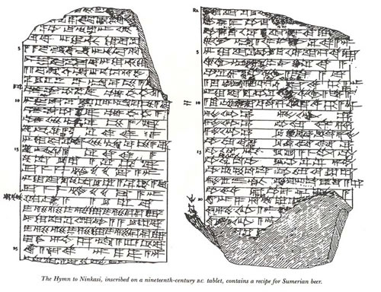
Other tablets from this region, ranging over a period of hundreds of years, suggest that most brewers were women, and that they undertook their occupation on both domestic and ritual scales. The Code of Hammurabi which is the oldest surviving book of law (c. 1700 BCE) indicates that tavern-keepers, who were likely producing the beer they sold, were women, and that they could be 'thrown in the river' if they cheated their customers—in short, their work was important enough to make laws about. We also read that the women tavern keepers who sold their beer, sold it for raw ingredients and not cash.
“If a beer seller do not receive barley as the price of beer, but if she receive money...or make the beer measure smaller than the barley measure received, they (the judges) shall throw her (the brewster) into the water.”
This is quite similar to a lot of homebrewers today (including myself) who make beer for friends in return for the supply of the ingredients.
Archaeological sites throughout the region have given us thousands of cuneiform tablets with recipes for and prayers in praise of beer and this evidence shows that these ancient brewsters were producing just as many different types of beer as today’s craft brewers, including black beer, white beer, red beer, beer of two parts, beer from the nether-world, beering for the offering (sacrifice), mother beer, beer for the supper, beer with horns, wheat beer and beer with a head.
Again, in ancient Egypt we see a very similar picture with women being the brewers and a goddess of brewing, called Tenenet who is mentioned in many texts dating from the Ptolemaic period as well as featuring in the Book of the Dead.
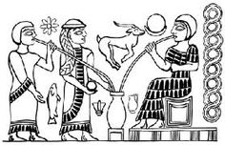
Hieroglyphs show Egyptian women both brewing and drinking beer, the later through a straw which historians say the Babylonian brewsters probably invented to pierce the thick layer of scum that floated on top allowing them to drink the clear beer underneath. Beer of the time being a much more basic produce which often still had the mash ingredients present. The Egyptian brewsters brewed their beer in an area of the kitchen called "the pure," with the lady of the house always supervising and it is said that men were not allowed to enter the pure for fear of contaminating the brew. Although royal brewers were sometimes men, most Egyptian beer was made and sold by women who, like the Sumerian brewsters developed scores of beer styles. Brown beer, iron beer, sweet beer-lagered with dates, neter or strong beer, white, black, red beer and Nubian "boosa"-the origin of our word booze-were just a few of the beer styles commonly made.
However, records suggest that as “production” breweries spread across Egypt to meet the needs of the many workers who were paid with beer, men replaced women as brewers, and those women were pushed into secondary roles. This corporatisation of breweries is a theme we will see repeat through history to the demise of the brewsters. This may also have caused Egypt and its most iconic female ruler’s demise. As the online Ancient History Encyclopaedia tells us, Cleopatra, Egypt’s last Pharaoh of consequence, “lost popularity toward the end of her reign, more for implementing a tax on beer (the first ever) than for her wars with Rome, which the beer tax went to help pay for.”
Coming geographically and chronologically nearer to home, from the 8th through the 10th centuries ACE (after the common era), it is said that Vikings spread terror throughout the civilized world in a state of ale-induced "berserk" they raped, burned and pillaged their way through North Africa, Holland, England, Ireland, Wales, France, Germany, and Italy (although many historians now argue that this image of the Vikings is inaccurate). This Viking brew was called AUL and from this word comes our English term ALE; a beer style that spread wherever the Norsemen conquered new lands. As with the ancient worlds we’ve already visited, we hear of women being the inventors and brewers of ale with the ancient Finns crediting the birth of beer to the efforts of three women preparing for a wedding feast. One of the women, Kalevatar combined saliva from a bear's mouth with wild honey and the gift of ale was born. From the Kalevala, the ancient Finnish epic about the creation of the world the importance of ale in human society is shown when the creation of ale is given twice the narrative space than is devoted to the creation of the world.
Women were the exclusive brewers in Norse society and again we see the importance of brewing and the brewsters enshrined in law saying that all brewhouse equipment remained the property of women only. In a time when women were generally seen as less than equal to men and not allowed to own property on their own this is a significant recognition of the importance of the role of women in brewing.

Medieval Britain and beyond: history and folklore
Throughout medieval Britain, beer was the safe alternative to drinking the dirty water that was available. As part of the women’s work of providing food and drink to their family, wives would brew low alcoholic beer for their families to drink throughout the day. Like it’s modern counterpart, the beer was made from grains and water, and then fermented with yeast. It was left to ferment in large, cauldron-like pots (more on this later).
In rural Britain (and rural Europe, think Saison), workers were often paid in pints rather than monetary wages and would often drink up to a gallon a day.
Brewing beer was yet another of the domestic duties of the women of the house, but as beer of this time was low alcohol and had no hops, it tended to spoil quickly. This meant excess beer could not be saved for another day, instead it became a mildly profitable vocation, allowing the brewsters or alewives as they were commonly known to sell their excess supply providing financial aid for the home. Unlike other trades that required land ownership, apprenticeships or education—all of which were out of bounds for women of the time—brewing was permitted because it didn’t involve leaving the home.
As late as the 13th century, English records show that less than eight percent of brewers were men. Beer remained an essential part of the diet and selling surplus beer became important to the economy of most households. When a housewife had extra beer to sell, an "ale-stake"-a long pole tied with branches and foliage or broom would be placed over the front door or in the road to let potential buyers know. We see this in many cultures with many types of flora hung from the ale-steak. Sometimes appearing as a garland of hops a top a broomstick, sometimes bunches of bright flowers, other times just the broomstick but the ale-stake is found in one form or another throughout the world in every primitive society from Africans, to the Amazon, and beyond to alert neighbours to the availability of fresh homebrew by displaying a staff hung branches or garland of fresh vines and flowers outside the brewster's hut. How this universal symbol of "beer for sale" came to be remains a mystery of the collective human unconscious.
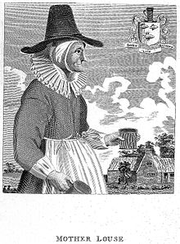
Some commercially savvy brewsters took things a step further and would take to the streets or markets to sell their beer. In busy markets, these women wore tall hats or peaked headdresses so that they could be spotted easily and the site of women in these hats became synonymous with brewsters selling their wares.
Although due to the takeover of Christianity in Britain we don’t have goddesses of beer, we have a “would be brewster” as an early church figure in the guise of Saint Brigid who, through an act of prayer and faith changed bath water into beer for a colony of thirsty lepers.
And then there is Hildergarde Von Bilgen, a German nun and an esteemed natural scientist and herbalist in the 12th century who discovered the influence of hops on increasing the life of beer. Bingen lived to the age of 81, which was ancient for her time. Must have been the beer.

The end of local brewsters and many local beers and traditions
During the Black Plague in the 14th centuary, so many people had died that Britain was left with a labour shortage. In turn, wages increased significantly and workers were able to spend more money on beer which in turn increased demand. This led to the opening of ale houses or taverns, and much like in ancient Egypt, production moved from the home and became more commercialised. With commercialisation in general, where there are profits to be made, brewing moved firmly into the hands of men who unlike female brewers, possessed the financial, cultural, and legal resources to conquer such a quickly expanding industry. And so the beardy boy’s club began.
With the advent of public taverns, women remained as brewsters, but unless widowed, could only hold a tavern license under a husband's name. Slowly, the brewing also fell to the men and as taverns and ale houses gave way to large commercial breweries, even the idea of women brewing died away.
This demise was helped in part by bad press. As beer was considered a vital food, good beer and honest measure were expected of ale wives and dishonesty was not tolerated. What had once been an honourable domestic duty, soon became tarnished by visions of alewives as cheats and even as loose women when taverns became associated with prostitution and low morals. Throughout England there are carvings and images of alewives being cast into hell for their sin of selling bad beer or for serving short measures. One such stone carving in a church in Ludlow, England shows the naked alewife wearing a peaked headdress and holding a false measure of ale being carried to a demon’s mouth, representing the jaws of hell. The pointed head dress is of the type the church considered a “devil’s snare”— thought to encourage an unhealthy interest in vanity at the expense of concern for the soul.
Sadly, by the late 18th century we saw the decline of brewing as a household art and the rise of the male-dominated "beer business" had begun. Along with commercial, large-scale brewing began a decline in the number of beer styles available to the public. Unusual, regional varieties of beer, developed by women through centuries of trial and error became first endangered and then extinct.

Brewsters, traditions and folklore
Women brewing appears throughout our folklore and traditions in Britain. One such tradition I’ve taken part in my self is the Brides-ale. Before weddings, a nuptial beer was brewed and sold, the proceeds going to the bride on her wedding day. These "bride-ales" survive in our word bridal. There was also "groaning" beer which was brewed for midwives and expectant mothers to be served during and after labour.
It’s not all fun and frivolity though. There were symbols associated with the brewster that unfortunately became associated with another female figure of folklore which may explain why so many churches have stone carving depicting brewsters riding demons to hell. The witch.
We’ve already explored how brewsters fermented their beers in large cauldron like pots where the yeast made the beer foam and bubble, that they sometimes put broomsticks outside their doors to let people know there was beer for sale or that they wore tall or pointed hats and head dresses to help them to be visible in a busy market. Unfortunately, as witch fever gripped Britain, it became easy for someone to accuse another of witchcraft, an accusation most women didn’t escape with their lives. If we add to our existing image of cauldrons, broomsticks and pointy hats and through in a family cat to stop mice from eating the store of grain, you can see how the folklore image of a witch may have been built.

So is that the end of the brewster?
There’s no denying that for a very long time, it would have been very unusual to see a woman brewing, any woman wishing to be a professional brewer would have found it very difficult to be taken seriously, even with thousands of years of brewing in her blood and the word brewster disappeared from our language but with the rise of artisan or craft brewing and small breweries so has there been a rise in women returning to the “craft” of brewing. There are still a great many more male brewers than women and female brewers still get called brewmasters and never brewster but we are seeing some fantastic female brewers joining the big breweries and winning awards.
Groups like the Pink Boots Society are being formed to support women on their brewing journey, marketing departments have accepted that that women drink beer and are marketing a much more positive and female friendly image of beer and even in homebrewing circles, women are winning the gold medals and running the homebrew clubs. The future looks bright.
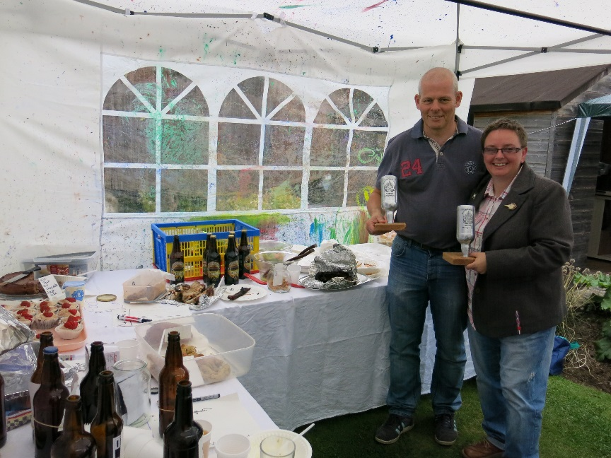
Eli winning another beer award - http://scottishcraftbrewers.org/?p=1544

References

Hymn to Ninkasi
Borne of the flowing water,
Tenderly cared for by the Ninhursag,
Borne of the flowing water,
Tenderly cared for by the Ninhursag,

Having founded your town by the sacred lake,
She finished its great walls for you,
Ninkasi, having founded your town by the sacred lake,
She finished it's walls for you,

Your father is Enki, Lord Nidimmud,
Your mother is Ninti, the queen of the sacred lake.
Ninkasi, your father is Enki, Lord Nidimmud,
Your mother is Ninti, the queen of the sacred lake.

You are the one who handles the dough [and] with a big shovel,
Mixing in a pit, the bappir with sweet aromatics,
Ninkasi, you are the one who handles the dough [and] with a big shovel,
Mixing in a pit, the bappir with [date] - honey,

You are the one who bakes the bappir in the big oven,
Puts in order the piles of hulled grains,
Ninkasi, you are the one who bakes the bappir in the big oven,
Puts in order the piles of hulled grains,

You are the one who waters the malt set on the ground,
The noble dogs keep away even the potentates,
Ninkasi, you are the one who waters the malt set on the ground,
The noble dogs keep away even the potentates,

You are the one who soaks the malt in a jar,
The waves rise, the waves fall.
Ninkasi, you are the one who soaks the malt in a jar,
The waves rise, the waves fall.

You are the one who spreads the cooked mash on large reed mats,
Coolness overcomes,
Ninkasi, you are the one who spreads the cooked mash on large reed mats,
Coolness overcomes,

You are the one who holds with both hands the great sweet wort,
Brewing [it] with honey [and] wine
(You the sweet wort to the vessel)
Ninkasi, (...)(You the sweet wort to the vessel)

The filtering vat, which makes a pleasant sound,
You place appropriately on a large collector vat.
Ninkasi, the filtering vat, which makes a pleasant sound,
You place appropriately on a large collector vat.

When you pour out the filtered beer of the collector vat,
It is [like] the onrush of Tigris and Euphrates.
Ninkasi, you are the one who pours out the filtered beer of the collector vat,
It is [like] the onrush of Tigris and Euphrates.

Stone carvings, paintings and prose depicting the evil ale wife
St. Laurence Church in Ludlow, c. 1425(Wood 1999, 45)
In another church carving, this time a roof boss from Norwich Cathedral
“Medieval doom” painting in St. Thomas Church, Salisbury
“The Tunning of Elinor Rumming” by John Skelton ([1718] 2010)
“Piers Plowman” William Langland

Ninkasi Award – American Homebrewers Association
This award is named for the Sumerian Goddess of beer and is given to the winningest brewer based on points earned in the Final Round of the National Homebrew Competition. Brewers earn points toward the award by placing in the 23 beer categories, three mead categories and two cider categories. To be eligible for the award, brewers must have at least one entry place in the 23 beer categories. Gold medals earn six points, silver medals earn four points and bronze medals earn two points.

Goddesses of beer
Accla: Incan female keepers of the sacred fires, who also brewed beer
The Accla were female virgins chosen by Inti (The Incan Sun God) to keep the sacred fires burning. In their spare time, they also brewed beer.
lbina: Arcadian, British & Irish White Barley Goddess
The White Barley Goddess, Albina was also known as Alphito. One of the earliest names for the British Isles, Albion, is thought to come from her name. The first modern microbrewery in the U.S. was called “New Albion Brewing.”
Ashnan: Mesopotamian/Sumerian Goddess of Grain
Ashnan, was the goddess of grain in Mesopotamia, and a goddess of drunkenness, wine & grains.
Cerridwen: Irish and Welsh Goddess of Barley and brewing
She also owned the “witches” cauldron of inspiration, which presumably she filled with barley to make beer, known as the “Brew of Inspiration and Knowledge.”
Gabjauja: Lithuanian Goddess of Grain
goddess of grain, fire and the hearth. According to one source, “she was a goddess of stack-yards and grain. Women made beer and bread for Gabjauja’s feast, which only kin would attend. The head of the family would pour a scoop of beer on the ground and say a prayer.
Ancient Scotland did the same thing with whisky
Icovellauna: Ouranian Goddess of Ale Brewing
In occult and magic circles, Ouranian Barbaric is a language and world all its own, and Icovellauna is their Goddess of Ale Brewing. She’s also often thought of a goddess of healing and a spring water deity, and is referred to as the “Divine Pourer of the Waters”
Mbaba-Mwanna-Waresa: Zulu Goddess of Beer
Mbaba-Mwanna-Waresa is the Zulu Goddess of fertility, the rainbow, agriculture, rain and beer; and the Zulus believed she made the first beer for her people. She’s also been known to create rainbows to signal it’s time to start drinking.
Medb: Irish Goddess of Intoxication
Medb was the Irish Queen of Connacht, as well as the Goddess of Intoxication.
Aegir’s Nine Daughters & Assistant brewers as their father brewed for the Gods of Asgard.
Yasigi: Mali Goddess of Beer

